MasterCard Personal Expense Management System (MPEMS)
Use Case Model Survey
Filing Reference : | MPEMS_T-1.3.1
Document Title : | Use Case Model Survey
Version : | 0.1a
Prepared By : | - JIANG HAO MIN  - ZHOU ZI FENG  - ALVIN LEE  - DAO XUAN DUNG
Date Created : | 08 Apr 2012
Review By : | Lee Zhong De
Revised Date : | 22 Apr 2012
©1993 ISS.  The information contained in this document is the property of ISS. The contents must not be reproduced, wholly or in part, for purposes other than for which it has been supplied, without the prior permission of ISS, or, if it has been furnished under contract to another party, as expressly authorised under that contract. ISS shall not be liable for any errors or omissions. | ISS
Revision History:

Version | Date | Author | Remarks
v0.1 | 08 Apr 2012 | - JIANG HAO MIN  - ZHOU ZI FENG  - ALVIN LEE  - DAO XUAN DUNG | Initial Draft
v0.1a | 22 Apr 2012 | - LEE ZHONG DE ROLLEI | Refer to amendment history

Distribution:
Name | Department | Organization
Huang Donghao | MasterCard | MasterCard
Dao Xuan Dung | S2 | ISS
Lee Zhong De Rollei | S2 | ISS
Alvin Lee | S2 | ISS
Guo Yu | S2 | ISS
Zhou ZiFeng | S2 | ISS
Jiang Hao Min | S2 | ISS

1. Introduction 5
1.1 Project Client Background 5
2. Survey Description 6
2.1 Non-registered Member Operations 6
2.2 Registered Member Operations 6
2.3 System Administrator Operations 7
2.4 MasterCard Centralized System Operations 7
3. Actors 8
3.1 Non-Registered Member 8
3.2 Registered Member 8
3.2 System Administrator 8
3.4 MasterCard Centralized System 8
3.5 SMS/Email Server 8
4. Use Cases 9
4.1 Login 9
4.2 Logout 9
4.3 Send Email/SMS 9
4.4 Register Account 9
4.5 Confirm Registration 9
4.6 Change Password 9
4.7 Manage Account Details 9
4.8 Manage Credit Cards 10
4.9 Manage Deals Subscriptions 10
4.10 Reset Password 10
4.11 View Dashboard 10
4.12 Assign Budget to All Cards 10
4.13 Assign Budget to Individual Card 10
4.14 Assign Spending Target to All Cards 10
4.15 Assign Spending Target to Individual Card 11
4.16 Create Credit Card Transaction 11
4.17 Compute Budget 11
4.18 Add Transaction Details 11
4.19 Export Transaction Data 11
4.20 Search Credit Card Transactions 11
4.21 Tag Transaction Type 11
4.22 View Credit Card Transactions 12
4.23 View Spending Pattern 12
4.24 Redeem Vouchers 12
4.25 Search Deals 12
4.26 Search Vouchers 12
4.27 View Recommended Deals 12
4.28 View Vouchers 12
4.29 Manage Deals 12
4.30 Manage Merchants 12
4.31 Manage Redemptions 12
4.32 Manage Vouchers 12
4.33 Manage Members 12
5. Use Case Diagrams 13
5.1 Non-Registered Member 13
5.1.1 Account Registration 13
5.2 Registered Member 14
5.2.1 Account Settings 14
5.2.2 Expense Assistant 15
5.2.3 Expense Tracker 16
5.2.4 Perks 16
5.2.5 Registered Member Global Use Case 17
5.3 System Administration 18
5.4 Common 18
6. Amendment History 19

Use-Case-Model Survey for MPEMS

1. Introduction

This project is an academic project supported by Institute of System Science (ISS, NUS). The project client is MasterCard Singapore. The project seeks to develop a system which will provide additional value added services to MasterCard customers. The value added services provided by the new system will enhance customer’s experience with MasterCard and ideally prompt the customers to choose MasterCard as their preferred card.

1.1 Project Client Background

Throughout the world, MasterCard’s principal business is to process payments between the banks of merchants and the card issuing banks or credit unions of the purchasers who use the "MasterCard" brand debit and credit cards to make purchases.



Currently if a customer holds multiple MasterCard from different banks, they will have to manually check their individual card transactions from their card respective banks which can be very inconvenient and time consuming.

The MasterCard Personal Expense Management System (MPEMS) seeks to provide the following value added services to all MasterCard holders

- Single point for user to check all their credit/debit cards transactions that are tie to MasterCard Payment Network

- Expense Tracker, allow user to track and analyze their expenses

- Budget Assistance, allow users to organize their budgets and set reminder when their spending exceed their pre-defined budget

- Exclusive MasterCard Deals, allow users to receive exclusive deals only for MasterCard users

- Rewards Program, allow users to earn reward points by spending on their MasterCard. The reward points can be used to exchange vouchers.

2. Survey Description

2.1 Non-registered Member Operations
The functions that Non-registered Member can perform with MPEMS through a user interface are as follows:

- Register Account
- Confirm Registration

2.2 Registered Member Operations
The functions that a Registered Member can perform with MPEMS through a user interface are as follows:

- Login
- Logout
- Change Password
- Manage Credit Cards
- Manage Deals Subscriptions
- Reset Password
- View Dashboard
- Assign Budget to All Cards
- Assign Budget to Individual Card
- Assign Spending Target to All Cards
- Assign Spending Targets to Individual Card
- Compute Budget
- Create Credit Card Transaction
- Add Transaction Details
- Export Transaction Data
- Search Credit Card Transactions
- Tag Transaction Type
- View Credit Card Transaction
- View Spending Pattern
- Redeem Vouchers
- Search Deals
- Search Vouchers
- View Recommended Deals
- View Vouchers

2.3 System Administrator Operations
The functions that System Administrator can perform with MPEMS through a user interface are as follows:

- Login
- Logout
- Manage Deals
- Manage Merchants
- Manage Redemptions
- Manage Vouchers
- Manage Memberss

2.4 MasterCard Centralized System Operations
The function that MasterCard Centralized System can perform with MPEMS is as follows:

- Create Credit Card Transaction

3. Actors

3.1 Non-Registered Member

The Non-Registered Member is an existing MasterCard holder who hasn’t registered in MPEMS. He/She is able to register on MPEMS to become a registered member.

3.2 Registered Member

The Registered Member is an existing MasterCard holder who has registered an account in MPEMS. The registered member will be able to use the various functions provided by MPEMS to track and manage his/her card expenditures.

3.2 System Administrator

The System Administrator interacts with the System by using the Admin functions provided by the System.

3.4 MasterCard Centralized System

MasterCard Centralized System will interact with MPEMS to create new transaction data.

3.5 SMS/Email Server

External SMS/Email Server will be used by MPEMS to send SMS/Email to Registered Member as part of the notification function

4. Use Cases

4.1 Login
This use case allows registered member and system administrator to (secured) login to the system. The system will direct users to member/administrator home page based on the login id and permission. To login to the system, the user will have to enter the login ID and password. The account will be suspended upon 3 failed login attempts

4.2 Logout
This use case allows registered member and system administrator who has already login to the system to logout from the system. User’s session will also be truncated.

4.3 Send Email/SMS
This use case allows the system to send an email or sms to registered members. This use case will be triggered by other use case as and when needed.

4.4 Register Account
This use case allows non-registered member to register an account into the system. To register an account, the user must have a valid MasterCard. After the user has registered with the system, an Email/SMS notification will be sent to the user. In order to successfully complete the account registration, the user must click on a link that will be provided in the email notification. Upon clicking the link, Use Case 4.5 will be triggered

4.5 Confirm Registration
This use case allows non-registered member to confirm his/her registration with the system. To trigger this use case, user will have to click on the link provided in the email. The confirmation registration page will be loaded; user will then have to enter the one-time-password that has been SMS-ed to his mobile phone. This confirm registration process helps to ensure that the email and mobile number provided by the user is valid. Upon successful confirmation, system will send an email to notify user that the account has been created successfully.

4.6 Change Password
This use case allows registered member to change password by entering the old and new password and confirming the new password by re-entering it. An email/SMS notification will be sent out to the user once the password has been change successfully.

4.7 Manage Account Details
This use case allows registered member to update their account information such as mobile number, email address and home address.

4.8 Manage Credit Cards
This use case allows registered member to add MasterCard to their account. Thereafter, transaction details can be downloaded for users to view. When member is no longer holding the card, he/she could remove the credit card from the account. Member could attached up to 8 MasterCard to their account.

4.9 Manage Deals Subscriptions
This use case allows registered member to subscribe and unsubscribe to different deals category. If the user is interested in electronic deals, he or she could subscribe to the deal category “Electronics”. The system will then based on user’s interest made appropriate deal recommendation to the user.

4.10 Reset Password
This use case allows registered member to reset his or her password. An email/SMS notification will be sent out to the user once the password has been reset successfully.

4.11 View Dashboard
This use case allows registered member to view the summary information of their expenditures. E.g. Total spending for this month, total points earned till date, last transacted amount etc. This is the default page after successful login.

4.12 Assign Budget to All Cards
This use case allows registered members to specify the budgeted amount (by weeks/months) for the combined expenditures of all cards registered under the account. The system will base on this setting to send out a notification (by email/SMS) if the budget is reached.

4.13 Assign Budget to Individual Card
This use case allows registered members to specify the budgeted amount for individual cards expenditure. The system will base on this setting to send out a notification (by email/SMS) if the budget is reached.

4.14 Assign Spending Target to All Cards
This use case allows registered members to specify the target amount to spend (by weeks/months) for the combined expenditures of all cards registered under the account.

4.15 Assign Spending Target to Individual Card
This use case allows registered members to specify the target amount to spend (by weeks/months) for individual registered card.

4.16 Create Credit Card Transaction
This use case will be exposed as a web service to allow MasterCard Centralized System (all real time transactions will go into this system) to create a new transaction record into the MPEMS. This use case will check if there is a pre-set budget set by the user, if yes, this use case will trigger use case 4.17 Compute Budget. If the spending exceeded the pre-set budget, this use case will trigger send email/sms use case to notify user.

4.17 Compute Budget
This use case may get triggered when a new card transaction is created. This use case will based on the budget control criteria (individual card budget, total budget, period) pre-set by the users to determine if the spending budget has exceeded. It will return the amount exceeded after the computation.

4.18 Add Transaction Details
This use case allows registered members to add in their own comments on individual card transaction. The comments added will help user to remember the purpose of the transaction. E.g. “Bought a watch for brother’s birthday”

4.19 Export Transaction Data
This use case allows registered members to download transaction data in CSV format. User could search/filter the transaction data before exporting it into CSV to be viewed offline or for archival.

4.20 Search Credit Card Transactions
This use case allows registered member to search through all their own credit card transactions. The registered member will provide the search criteria e.g. transaction start end date, search credit card, search by comments etc.

4.21 Tag Transaction Type
On default, all transactions record will be tagged to a category based on the merchant id. This use case allows registered members to modify the transaction category when required. The purpose of this function is to allow users to group their expenditures into different category such as clothes, food, petrol etc based on their requirements

4.22 View Credit Card Transactions
This use case allows registered members to view specific credit card transactions.

4.23 View Spending Pattern
This use case allows registered members to view spending pattern by period, cards or transaction type in the form of bar chart or line chart.

4.24 Redeem Vouchers
This use case allows registered members to redeem vouchers using their reward points. Registered member could search for the list of redeemable vouchers.

4.25 Search Deals
This use case allows registered members to search for all existing MasterCard deals

4.26 Search Vouchers
This use case allows registered members to search for all vouchers redeemable by members

4.27 View Recommended Deals
This use case allows registered members to view recommended deals based on MPEMS personalized recommendation algorithm

4.28 View Vouchers
This use case allows registered members to view all vouchers redeemable by members

4.29 Manage Deals
This use case allows system administrator to search, create, retrieve, update and delete master card deals.

4.30 Manage Merchants
This use case allows system administrator to search, create, retrieve, update and delete merchants

4.31 Manage Redemptions
This use case allows system administrator to search, retrieve and update redemption status.

4.32 Manage Vouchers
This use case allows system administrator to search, create, retrieve, update and delete vouchers redeemable by members

4.33 Manage Members
This use case allows system administrator to search, retrieve and view member account information. This use case also allow system administrator to update member’s account status

5. Use Case Diagrams

5.1 Non-Registered Member Use Cases

5.1.1 Account Registration

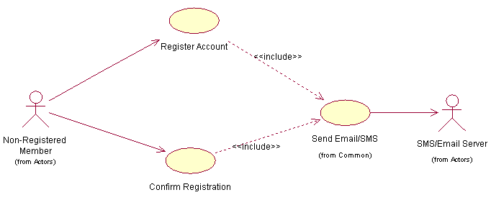

5.2 Registered Member Use Cases

5.2.1 Account Settings

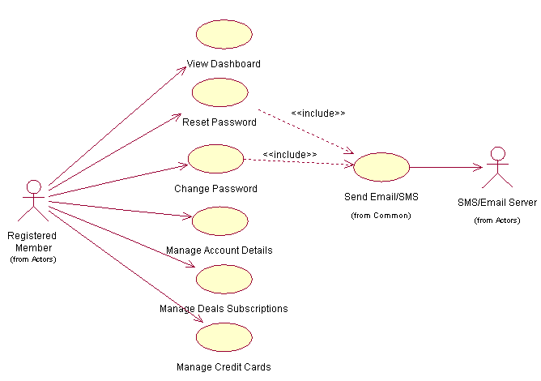

5.2.2 Expense Assistant
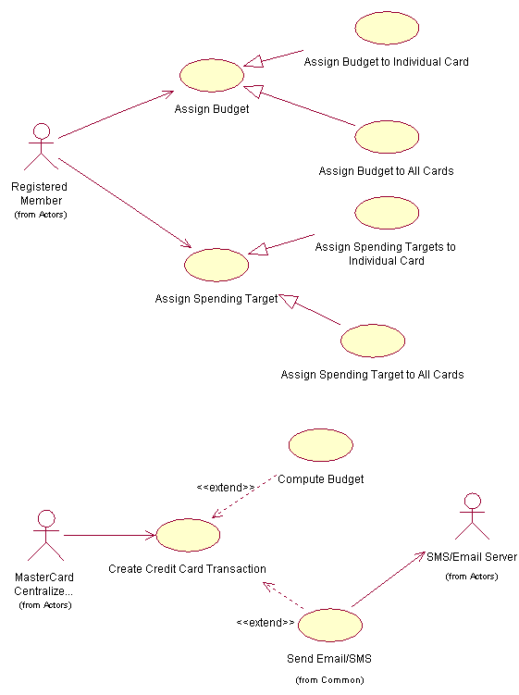

5.2.3 Expense Tracker

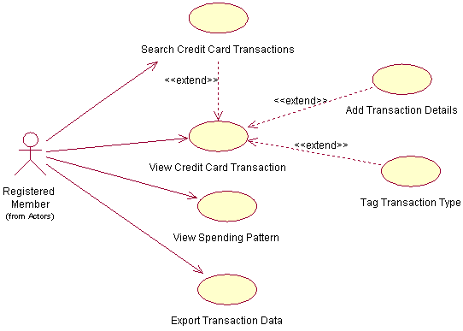

5.2.4 Perks

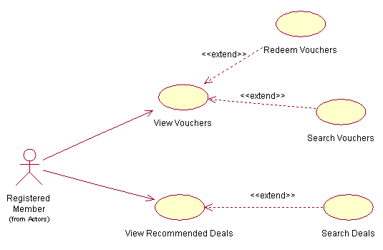

5.2.5 Registered Member Global Use Case
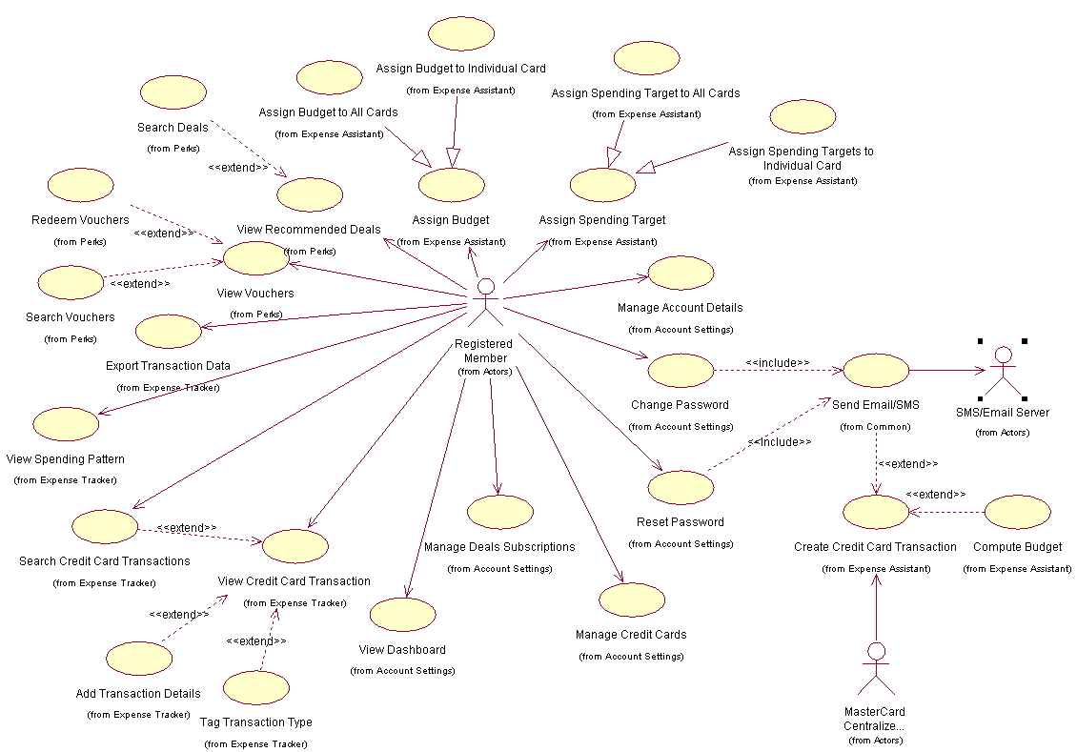

5.3 System Administration Use Cases

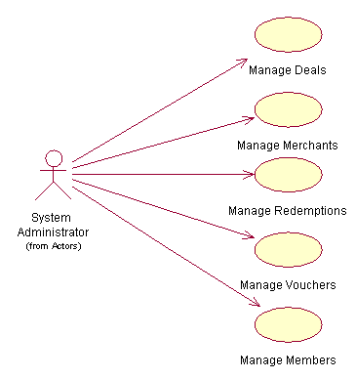

5.4 Common Use Cases

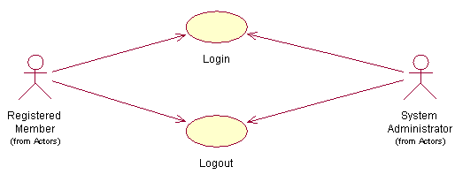

6. Amendment History

Version | Section | Remarks
v0.1 | 08 Apr 2012 | Initial Draft
v0.1a | 22 Apr 2012 | - Changed format to adhere to MPEMS document format  - added new use case “View Dashboard”  - added in missing actors

